**VIETNAM NATIONAL UNIVERSITY – HO CHI MINH CITY**  
**INTERNATIONAL UNIVERSITY**  
**SCHOOL OF COMPUTER SCIENCE AND ENGINEERING**



THESIS REPORT

**Nguyễn Thành Thiện**

**ITITIU14089**

**SPORT EVENTS MANAGEMENT MOBILE APP**

by

**NGUYEN THANH THIEN**

***Submitted to:*** School of Computer Science and Engineering - International University, VNU-HCM

APPROVED BY SUPERVISOR APPROVED BY: COMMITTEE

____________________________ ___________________________

Tran Thanh Tung, Ph.D. Assoc. Prof. Chair Tran Manh Ha,

_______________________________

_______________________________

_______________________________

_______________________________

**Thesis committee**

# **ACKNOWLEDGMENTS**

First of all, I want to express my most profound appreciation for Mr.Trần Thanh Tùng, who has carefully guided me and also pushed me for the best in the project. He is my advisor at the university. I was impacted by his advice on my career path, on the industry and my next step after graduating. His knowledge and experiences helped me a lot on the way of completing my thesis.

Subsequently, I want to thank my family, my girlfriend, who always support me in the life. They still at my back and encourage me every time I was down mood.

Furthermore, I would like to express my gratefulness for my friends. They helped me very much to make me become more perfect.

I want to thank all of my colleagues, they helped me very much in the job and also give me many practical experiments for my ultimate way.

**TABLE OF CONTENTS**

Chapter I. Introduction 1

**1. Problems and Objective1**

**1.1. Problems1**

**1.2. Objective2**

**3. System requirements3**

[**3.1. React (React Native and React Js)3**](#_3.1._React_(React)

**3.2. Why React Native3**

***3.2.1. Saving time and reducing development costs 3***

***3.2.2. Performance 4***

***3.2.3. Reusability*** ***5***

***3.2.4. Maintainability*** ***6***

**4. Goal** **6**

Chapter II. BACKGROUND 7

**1. Flux and Redux** **7**

**1.1. Flux** **7**

**1.2. Different of Flux with MVC** **9**

**1.3. Redux** **10**

**2. Node.js 1****2**

**2.1. Definition 1****2**

**2.2. How Node.js works 1****2**

**2.3. Node Package Manager - npm 1****4**

**3. Firebase 1****6**

**3.1. Cloud Function 1****6**

***3.1.1. Definition1******6***

***3.1.2. Using Cloud Function 1******6***

***3.1.3. Why Cloud Function 21***

**3.2. Real time database** **21**

***3.2.1. Definition******21***

***3.2.2. Using Realtime Database 2******2***

***3.2.3. Why Realtime Database 2******4***

**3.3. Authentication 2****5**

***3.3.1. Definition2******5***

***3.3.2. Why Authentication 2******5***

**4. Expo 2****6**

**4.1. Expo CLI 2****7**

**4.2. Expo log 2****8**

**4.3. Why Expo 2****9**

**5. Open source** **30**

**5.1. react-native-maps** **30**

**5.2. react-native-elements** **30**

**5.3. geolib** **30**

**5.4. react-native-scrollable-tab-view** **31**

**5.5. material-ui** **31**

**Chapter III. SYSTEM ARCHITECTURE 3****3**

**1. Use case by user-stories3****3**

[**1.1. User (visitor, member) 3**](#_user_(visitor,_member).)**3**

**1.2. Owner, Administrator3****8**

**2. Diagrams** **41**

**Chapter IV. IMPLEMENTATION 4****5**

**1. Layers, Functions4****7**

**1.1. Mobile application 4****7**

***1.1.1. Overall structure 4******7***

***1.1.2. Push Notification*** ***50***

***1.1.3. Map View 5******4***

***1.1.4. Camera 5******6***

**1.2. Web application57**

***1.2.1. Overall structure 5******7***

***1.2.2. UI component – Material UI 5******8***

**1.3. Redux implementation – react-redux5****9**

**1.4. Firebase – Realtime Database** **62**

**2. Result** **64**

**2.1. Mobile application****64**

**2.2. Web application** **70**

**Chapter V. CONCLUSION** **75**

**1. Experiences** **75**

**2. Conclusion****75**

**REFERENCES** **77**

**LIST OF FIGURES**

Figure 1 - Flux architecture 1

Figure 2 - Redux life cycle 1

Figure 3 - Traditional web-serving techniques 1

Figure 4 - Node.js workflow 1

Figure 5 - npm install command 1

Figure 6 - npm configuration command 1

Figure 7 - Cloud Function implementation path 1

Figure 8 - Firebase push notification model 1

Figure 9 - Firebase chatbox model 1

Figure 10 - Firebase image storage model 1

Figure 11 - Firebase CI/CD management 1

Figure 12 - Usage of cloud functions 1

Figure 13 - Database is synchronized at real time 1

Figure 14 - Four types of Security Rules 1

Figure 15 - Rules of user data accession 1

Figure 16 - Expo CLI after ran start command 1

Figure 17 - Expo Web Browser UI 1

Figure 18 - Use case diagram for client 1

Figure 19 - Use case diagram for server 1

Figure 20 - Sport Events Management Class diagram 1

Figure 21 - Applying technologies into project 1

Figure 22 - React Life Cycle 1

Figure 23 - Redux Model 1

Figure 24 - Firebase features 1

Figure 25 - Code structure 1

Figure 26 - Applying of Redux 1

Figure 27 - Firebase cli 1

Figure 28 - Initialize Firebase function 1

Figure 29 - Write function to send Push Notification in “Index.js” 1

Figure 30 - Register device’s token and update database to receive notification in UI component 1

Figure 31 - Google Cloud console of managing API keys 1

Figure 32 - Expo configuration file 1

Figure 33 - Google provider in Map view 1

Figure 34 - Actions inside Camera component 1

Figure 35 - Camera component 1

Figure 36 - Image processing in client 1

Figure 37 - Web application code structure 1

Figure 38 - Material UI components 1

Figure 39 - Material UI component's props 1

Figure 40 - Material UI Complex components 1

Figure 41 - Initialize redux in application 1

Figure 42 - Redux component combine all reducers 1

Figure 43 - Initialize store in application 1

Figure 44 - Redux actions implementation 1

Figure 45 - Connection between Component and Redux 1

Figure 46 - Redux calling actions in component 1

Figure 47 - Firebase config and constant references 1

Figure 48 - Firebase database references 1

Figure 49 - Firebase push database 1

Figure 50 - Firebase Realtime Database view 1

Figure 51 - Firebase synchronous database in real time 1

Figure 52 - Using authentication in application 1

Figure 53 - Login screen 1

Figure 54 - Main screen 1

Figure 55 - News tab contains all available events 1

Figure 56 - Tournaments tab contains specific responded events 1

Figure 57 - Map view tab 1

Figure 58 - Map view tab, radius filter 1

Figure 59 - Personal tab, permission required 1

Figure 60 - Background theme, push notifications 1

Figure 61 - Camera screen 1

Figure 62 - Gallery screen, temporary storage 1

Figure 63 - Image modal review 1

Figure 64 - Sign in page 1

Figure 65 - Event page 1

Figure 66 - Filter and update events 1

Figure 67 - Delete events 1

Figure 68 - Added new event 1

Figure 69 - Adding event steps 1

# **I. INTRODUCTION**

## **Problems and Objective**

With the development of society, the application of modern technology is more and more popular in our world, especially of using phone in daily life. Today's phones can meet most user requirements, from keeping contacts, taking photos/videos to serve entertainment purpose such as music, games, etc.

One of the benefits of a modern phone (smartphone) is that users can select their favorite applications and use them independently as regular web applications.

Applications that are the most popular have basic requirements such as tracking the status of an in-app object, finding an object, controlling personal information from the application and the interaction between users and apps, etc.

With my product (called "Sport News"), you can use the functions needed for specific sport community events in your area.

### **1.1. Problems**

For the purpose of carrying all the news from sports events in the area, there are too less applications used to track in the smartphone. There is also the limitation of selection, and the user cannot know details about their favourite kind of sport. Because the event positioning system has not been applied with small events, community users cannot follow and give comments about any events around them (such as feedback, live video, picture, etc.).

It is also a problem in server side when almost owners cannot find a good way to give their events to people in a smartphone by the native application. Although the user's solution is a native mobile application, manage it by smartphone is not a smart decision because there are many parts (such as image pixel, link, etc.) that are hard to process by the mobile application.

### **1.2. Objective**

In my project, I will develop an application for the mobile user and a web application for event owners. It includes the following special features:

+ Realtime Push Notifications about the event into customer’s phone: Users can know everytime a new event is created around them, and they can select what kind of sport they want to get the notification.

+ Capture their moment using to review the event: Using full service of a smartphone like camera to give user's comment and public it.

+ Tracking events by real-time map and GPS: Give the current position of events, and also give map view a filter.

+ A web application: Web application for event owner to manage their event.

## **3. System requirements**

### **3.1. React (React Native and ReactJs)**

React was introduced and developed by Facebook, the biggest community network in the world. React was created to optimize the DOM handling (by saving the state of an application and change the DOM when the state changed). By this way, it is really helpful with constant data.

Besides that, React Native is a framework that lets you build native iOS and Android apps with one unique language of Javascript. React Native provides a virtual DOM (Document Object Model) which is a generic representation of what your UI will look like independent of the two platforms. React Native then renders the native control based on your UI markup representation which then renders native controls. It is able to take native platform components (sliders, switches, labels, tab bars) and wrap them in React component counterparts.

### **3.2. Why React Native**

#### ***3.2.1. Saving time and reducing development costs.***

*\* Easy to learn*

Getting started with React Native is easy - especially for JavaScript professionals. Just download the open-source code from Github and make sure you’re familiar with a few tools and constructs in the React Native library including NodeJS, the CSS Flexbox system, ECMAScript 6, and JSX.

* Cross-platform

React Native was originally only developed for iOS support, but due to its success and popularity, Facebook decided to develop support for Android as well, so which translates to lower development costs.

*\* The ability to combine good features and build apps*

Whereas native app development is usually associated with inefficiency, less developer productivity, and slower time to deployment, React Native brings the speed and agility of web app development to the hybrid space with the native result (the combination between pros of Hybrid and Native apps).

React Native provided "Hot Reloading" (the previous version is “Live Reloading”) that keeps the app running and to inject new versions of the files that you edited at runtime. By this, you don't lose any of your state which is especially useful if you are tweaking the UI. The result is timed between you save a file and be able to get this feedback loop can be under 1 second, even as your app grows.

#### ***3.2.2. Performance***

Traditionally, “Hybrid” or “Mobile web” apps that work on both iOS and Android tends to go down for more complicated apps. Apps built through React Native are compiled into natively written code, so they not only work on both operating systems, but also function the same as a natively written app (**“learn once, write anywhere”**).

React Native is focused solely on building a mobile UI, making it more like a JavaScript library than a framework. It is developed based on Facebook’s popular ReactJS UI library for web applications, so it brings all of ReactJS’s better app performance: DOM abstraction, and simplified programming methods to hybrid mobile development. The resulting UI is highly responsive and feels fluid (the app will have quicker load times than a typical hybrid app, and a smoother feel) thanks to asynchronous between Javascript and Native.

#### ***3.2.3. Reusability***

Reusability is key to React Native. That means the building blocks are treated as native components that can be compiled directly into the native languages (Objective-C for iOS and Java for Android). This is a huge bonus for businesses that want to augment an existing app but don’t want to overhaul it by Incorporate React Native components into the app’s code.

This is possible to exclude the WebView components of other Hybrid mobile apps because React Native’s building blocks are reusable “native components” that compile directly to native. For example, if you’re adding Google Maps functionality to your app, React Native lets you link the plugin with a native module without having to rely on a WebView for certain functions. Components you would use in platforms have counterparts right in React, so you’ll get a consistent look and feel.

#### ***3.2.4. Maintainability***

React Native uses Javascript and this, coupled with the intuitive architecture of the framework itself, allows engineers to jump to and from each other’s projects on Native apps with relative ease.

The typical workflow would consist of writing most of the code on React Native and then using the native languages to optimize certain elements of the app. Parts of a specific app written in React Native will have no trouble combining with parts written in the native languages for iOS or Android. It is entirely up to the developer to build the app, it not only can the native languages of an OS be used to optimize an app, but they can also be used to write parts of the app.

## **4. Goal**

After developed the project, I want to gain the needs that:

+ Having an application for the user to track sports community events (in both client-server sides).

+ Using React to build an application (on both smartphone and web environment) with smoothly.

+ Applying Firebase into future projects as a steady server to store and analyze data.

# **II. BACKGROUND**

## **1. Flux and Redux**

### **1.1. Flux**

Flux is an architecture for creating data layers in JavaScript applications. It was designed along with the React view library. It places a focus on creating explicit and understandable update paths for your application's data, which makes tracking changes during development simpler and makes bugs easier to track down and fix.

Flux consists of the following basic components:

**+ Action:** This is the place to register the functions that will be called when View needed.

**+ Dispatcher:** Has the role of transmitting calls from Action to the Store. When an Action is called, the Dispatcher will broadcast an event to all Stores, with Action Type, or any other required data.

**+ Store:** The place to store data is also the only place where you can add, edit or delete data. The store will listen to the events that come from the Action through the Dispatcher, check that the event is under its processing, and make the necessary data changes, corresponding to each event. After changing the data, Store will give another event to report its change.

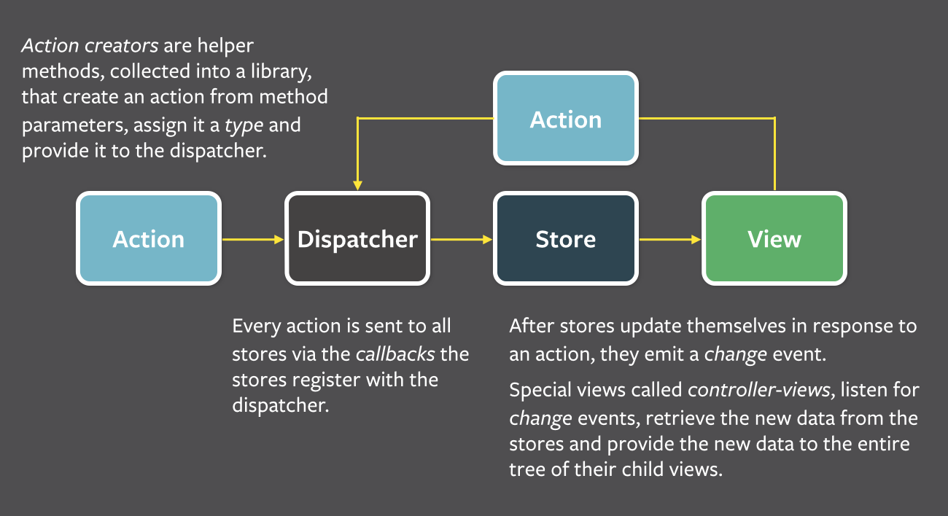**+ View:** Retrieves data from functions.

Figure 1 - Flux architecture

React using **one-way data bindings**, because they think that two-way data bindings will become "When one object update, it many other objects will update, and then makes more updates". With one-way, when all the changes go to the Dispatcher, they can easily find where the change comes from, so the system will become "predictable".

Flux follows the concept of **Unidirectional Data Flow** (UDF is to keep the data flow in the application moving in a single direction. When the data changes, this stream reboot from scratch) making it much easier to zero in of where the error lies. The data goes through a strict pipeline through your application:

+ Any changes, or Actions, must go through the Dispatcher!

+ Store is just only public getter, not the public setter. Data change handlers can only be called inside the Store itself. This means:

+ You cannot change the data in the Store directly from the View.

+ You also can not change the data in one Store from another. As mentioned above, Store is not the public setter. To do that, you must go through Action and Dispatcher. This makes the data inside your Store more manageable, you can easily debug where the change comes from when data changes.

### **1.2. Different of Flux with MVC**

*\* Easier to understand the data flow.*

In the bidirectional data flow, you have the typical data flow   MVC. But when applications became more complex, the Controller takes the huge responsibility of maintaining both the application state and the data. Also, the cascading updates make the app difficult to understand and debug.

With UDF, changes in the application view layer will trigger an action in the data layer. These changes will then be reflected in the View. The View does not directly affect application data.

*\* Reducing the role of Controller.*

Dispatcher is not a controller; it does not contain business logic. It simply is a "coordinating centre", which send an Action to every Store. In the MVC model, you can design any Controller as you can. But in Flux, there is only one Dispatcher and all Actions must go through it. The appearance of the Dispatcher is important because it ensures the design of UDF.

*\* Store can handle many objects.*

In the MVC model, the Model usually manages a particular object. In opposition to the Model, the Store may not handle any data or handle multiple states of the application, or manage various objects at once.

### **1.3. Redux**

Redux is an implementation library of Flux with minimal API but entirely predictable behaviour, so it is possible to implement logging, hot reloading, time travel, universal apps, record and replay, without any buy-in from the developer.

Redux can be used together with React, or with any other view library, and following three principles:

+ All application state is contained within a ***single store***, which is most often a JavaScript object.

+ The application's state is ***immutable***. This means that at no point should the object representing the state be modified in any way by any component.

+ All functions that compute the new state (called reducer functions) must be **pure functions**. Pure functions are functions that produce no side-effects and are deterministic - for a given set of inputs, the output will always be the same.

General structure of Redux design pattern:

+ ***actions*:** Are payloads of information that send data from your application to your store. They are the only source of information for the store

+ ***reducers*:** Reducers specify how the application's state changes in response.

+ ***stores*:** The actions that represent the facts about “what happened” and the reducers that update the state according to those actions. The Store is the object that brings them together.

+ ***components:*** Folder contains the components that are only responsible for the view and receive user interaction (How things look: markup, styles). These files read and change data from props => Dump components.

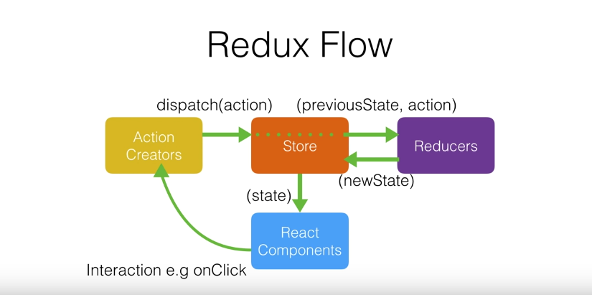+ ***container:*** The components that are aware of Redux, Router, etc. They are more coupled to the app. They transmit the data to dump components with *props* (How things work: data fetching, state update) => Smart components.

Figure 2 - Redux life cycle

## **2. Node.js**

### **2.1. Definition**

Node.js is a compilation of Google’s V8 JavaScript engine and great library environment for executing JavaScript functions outside the browser. It is also a helpful multi-platform to create a web application and server-side. Node.js provides a great model which makes it become very lightweight and can do smoothly with information serious. It also has a rich JavaScript's library modules to decrease the complication of applications.

### **2.2. How Node.js works**

It uses non-blocking, event-driven I/O paradigm to stay lightweight and valuable to handle real time problems and multi-client side.

=> Node.js is just a platform to server several kinds of needed.

To optimize the lightweight feature, and then it is possible to expand a huge number of connections quickly with high instability.

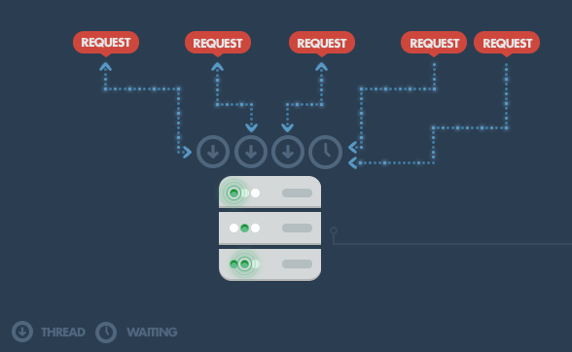Node.js operates a single thread for all concurrent connections => Help to reduce the weight of RAM which was really a big problems of traditional web services when they always create new thread for each connection.

Figure 3 - Traditional web-serving techniques

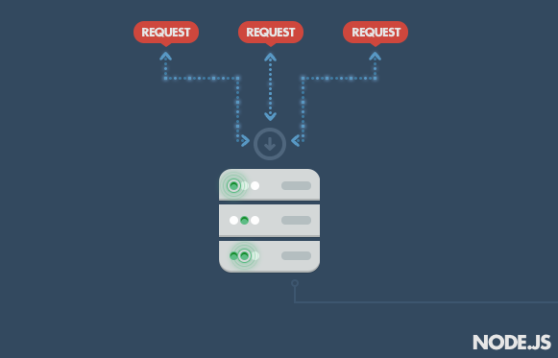

Figure 4 - Node.js workflow

### **2.3 Node Package Manager – npm**

npm is a tool go with every Node.js version. It is a built-in support for package management. It includes set of all needed dependencies, publicity and reusable components with versions stored at an online reposistory.

=> Using npm CLI to install a huge module ecosystem, even publish your own modules.

To use npm CLI, pass following command pattern:

npm <command> [args]

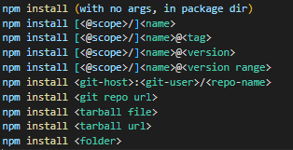

Figure 5 - npm install command

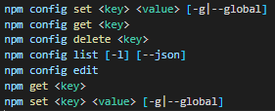

Figure 6 - npm configuration command

To fix installed modules by default, using command:

npm audit fix

In React project, using npm is a fundamental part and through npm, we can find more helpful modules to develop and optimize application.

## **3. Firebase**

### **3.1. Cloud Function**

Cloud Function will trigger a function (backend code) to run HTTPS requests, and Firebase features automatically. It likes a tool help to manage your server, and your code is stored in Google's cloud.

#### ***3.1.1. Definition***

Cloud Function is an event-driven computing service and does not need a server. Instead of having basic infrastructures such as servers, storage and other resources, developers can use Cloud Function to implement and initialize functions in Google's public cloud.

#### ***3.1.2. Using Cloud Function***

A Life cycle of function includes:

+ Define a new function (two support languages for writing are Javascript and Typescript) -> Choose an event provider -> how to execute the function.

+ Deploy function, Firebase will automatically connects to provided event.

+ When function's conditions is called -> functions is deployed -> The code is invoked.

+ Google will handle the sessions of function, if there are many events -> create more instances and vice versa.

+ When function is updated, all old versions will be replaced by the new one.

+ When the function is removed, all things will be cleaned up, including the connection between function and provided event.

So we can say that it is implemented by 3 steps:

+ Set up: Install Firebase CLI and initialize Functions in the project.

+ Implement: Write the function by Javascript/Typescript language.

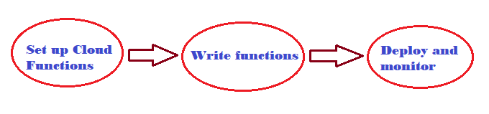+ Deploy or update: Using CLI to deploy function and view log in the Firebase console.

Figure 7 - Cloud Function implementation path

* Usage of Cloud Function:

- Notify users when something interesting happens:

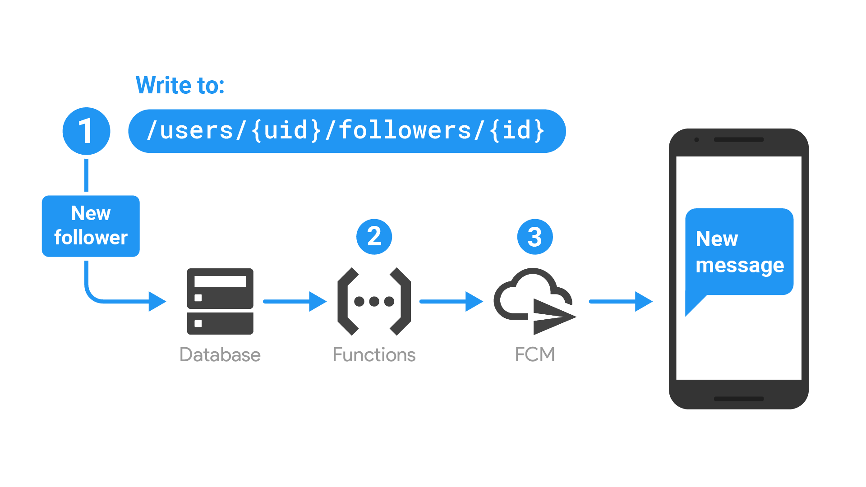

Figure 8 - Firebase push notification model

+ The function is triggered when database was updated.

+ Function execute to compose a message to send by using Firebase Cloud Messaging.

+ When Firebase Cloud Messaging is executed, a notification is sent to user’s device.

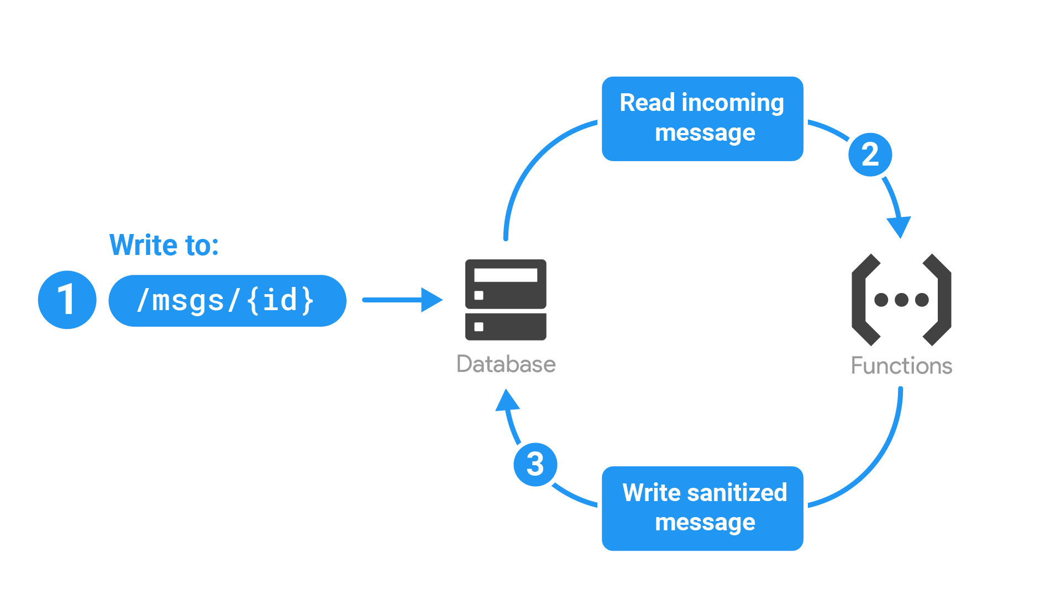- Perform Realtime Database sanitization and maintenance

Figure 9 - Firebase chatbox model

+ The function is triggered when database is written to store -> retrieving event data containing the text message.

+ Function execute to detect and handling text message.

+ Function send back an update to database.

- Execute intensive tasks in the cloud instead of in your app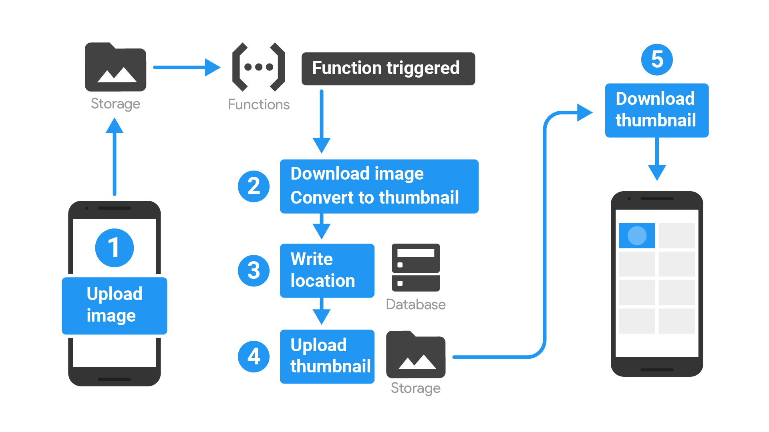

Figure 10 - Firebase image storage model

+ When image is uploaded to storage -> a function is triggered.

+ Image is downloaded and convert to thumbnail (resizing/cropping).

+ Function save that thumbnail’s location into database -> client side can interact with thumbnail’s location.

+ Thumbnail is uploaded back to new location -> download via thumbnail link.

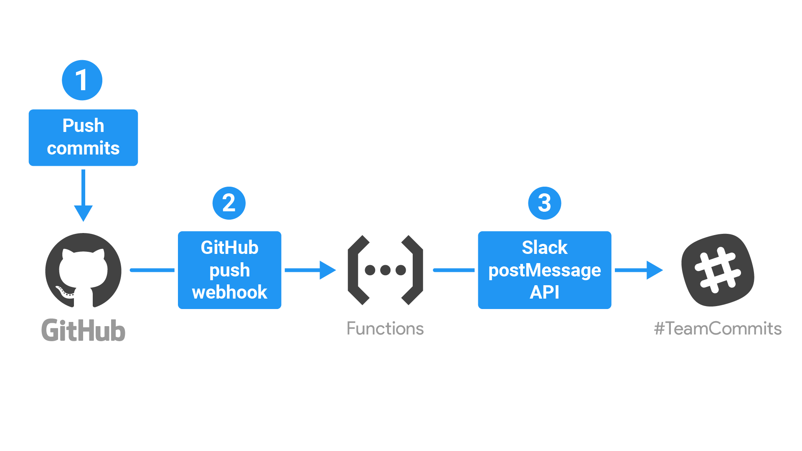- Integrate with third-party services and APIs

Figure 11 - Firebase CI/CD management

+ When a commit is pushed into Git -> function is triggered via Git webhook API.

+ Function send notification (Slack postMessage API) into Slack.

#### ***3.1.3. Why Cloud Function***

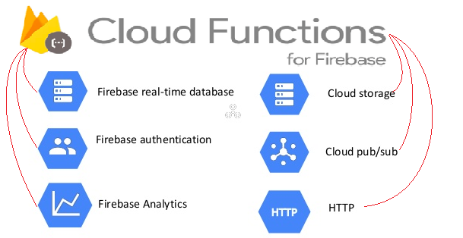Cloud Function can integrate with other features of Firebase and respond to the created event, helps to limit ordinary code and making easier to use Firebase.

Figure 12 - Usage of cloud functions

Server configures automatically and scales up the resource. After deploy function, The problems of server connection or server credentials is executed automatically.

Cloud Function fully isolate with client side, so logic function is secured and avoid the code to be reverse engineered.

### **3.2. Real time database**

#### ***3.2.1. Definition***

Firebase Realtime Database is a cloud-hosted database, using real time to update and receive newest data between clients – server.

Is a NoSQL database and as such has different optimizations and functionality compared to a relational database. Data is stored as Json object and synchronized in real time to every connected client.

Data is remain unchanged when clients go offline.

#### ***3.2.2. Using Realtime Database***

You can build an application with secure access from client, and give the responsive experience and even if client goes offline, it can automatic merge and conflict.

Realtime Database uses Security Rules as an expression-based rules language to limit how data can be read and written. We can integrate Realtime Database with Authentication to manage the data accession.

Data can be used to build a massive experience of real time to users and no need to worry about compromising on responsiveness. Realtime operation is executed very quickly and then can optimise the functionality.

Firebase Realtime Database implementation path:

+ Integrate Firebase Realtime Database: Using Gradle (Java Android), CocoaPods (Swift iOS) or Javascript (React).

+ Set up data (create/remove/update): Using Json object structure to create data references.

+ Database event: Listen even to write data or change data.

+ Enable Offline Persistence: Allow data to be written to the device's local disk so it can be available while offline.

+ Secure data: Using Security Rules to define who can read or write the data of application.

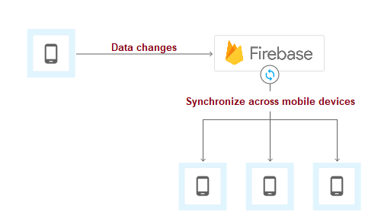

Figure 13 - Database is synchronized at real time

* Firebase Realtime Database Rules:

Security Rules has four types with Javascript-like syntax

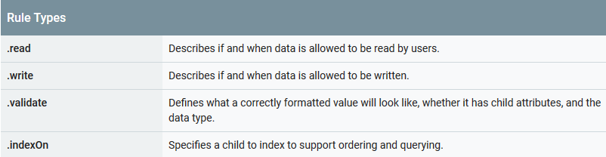

Figure 14 - Four types of Security Rules

To set your own rule to protect the database and set permissions authentication.

There are several kinds of security to run application:

+ Authentication: A security concept to identify users. Using authentication to accept that user information is possible to run application.

+ Authorization: After Authentication, use Authorization to allow user access to the data, respectively. Authorization help to determine whether user can only read data or have permission to write and change data.

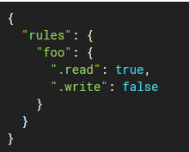

Figure 15 - Rules of user data accession

+ Data validation: Firebase Rules apply validation logic to help the data become consistent, it is called validation rules and it does not cascade => must evaluate to true in order for the write to be allowed.

+ Defining database indexes: Before launching your app though, it is important to specify indexes for any queries you have to ensure they continue to work as your app grows [3].

#### ***3.2.3. Why Realtime Database***

Data is synchronozed every time data changes and with a lightweight APIs, the data speed updated to clients is counted by milliseconds

Firebase apps remain responsive even when offline because the Firebase Realtime Database SDK persists your data to disk. Once connectivity is reestablished, the client device receives any changes it missed, synchronizing it with the current server state [4].

Based on Security Rules, we can determine whether or not data is access from clients so that it can be accessed directly from client side (mobile devices or web application) and do not need a server side.

With Firebase Realtime Database on the Blaze pricing plan, you can support your app's data needs at scale by splitting your data across multiple database instances in the same Firebase project. Streamline authentication with Firebase Authentication on your project and authenticate users across your database instances. Control access to the data in each database with custom Firebase Realtime Database Rules for each database instance [5].

### **3.3. Authentication**

#### ***3.3.1. Definition***

Firebase Authentication gives you a backend services to identify users, then makes user data become personalize.

It provides good libraries to identify user by passwords, phone numbers, mails and even popular web services like Google, Facebook, etc.

#### ***3.3.2. Why Authentication***

Easy to develop your application’s Login page. By using Authentication, sign-in functions will work quickly and efficiently.

A drop-in authentication solution to identify by username - password or any identification methods.

The best solution for mobile and web application render sign-in UI. Go with that are other problems related to account like account linking, account recovery and sign-up function etc.

It is customizable. Developers are not constrained in realizing the user experience.

## **4. Expo**

Expo is a set of tools, libraries and services help to develop mobile application using React Native.

Expo uses React natives apps contain its SDK, which provides your accession to device's system functionally (camera, contact, local storage, GPS, etc.).

It also offers simple UI components used for a mobile app such as Text, Touchable, View, etc.

Expo SDK provides access to services and calls some general functions like Push Notification, Sign in with Google/Facebook, etc., and you can build native code within your React Native project using Expo efficiently.

### **4.1. Expo CLI**

Expo CLI (command-line interface) is a developing tool associated with UI and Web Browser, which can show the project's logs and device information to manage and develop the application.

To use Expo CLI, you first must have NodeJS (version 6 or newer) in your environment.

First install Expo CLI, run command:

npm install -g expo-cli

After installed Expo CLI, and start an Expo project by run following commands:

expo init *<project_name>*

cd *<project_name>*

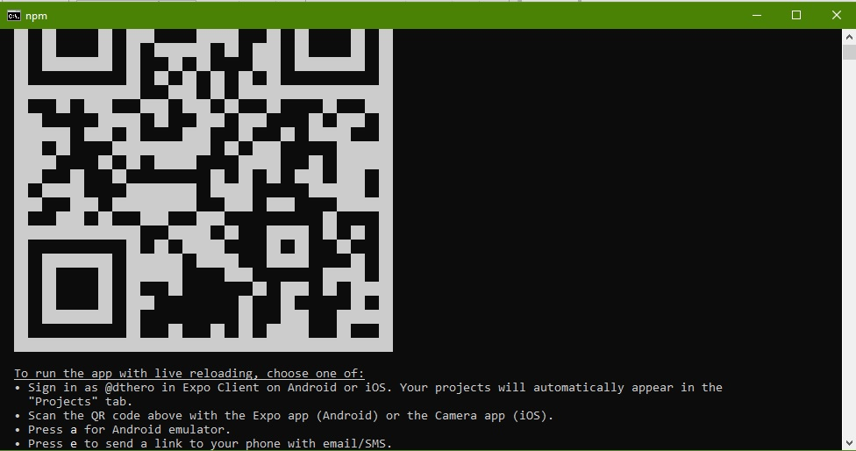expo start

Figure 16 - Expo CLI after ran start command

A new Web Browser will show up for you with options to run project:

+ Run by the real device. In target device, install Expo client app from play store and open it, then we can build the project on the device via phone number (send build link into phone number as a message) or scan QR code on Web Browser.

+ Run by simulator. You must have a virtual device on your build environment and connect to build tool.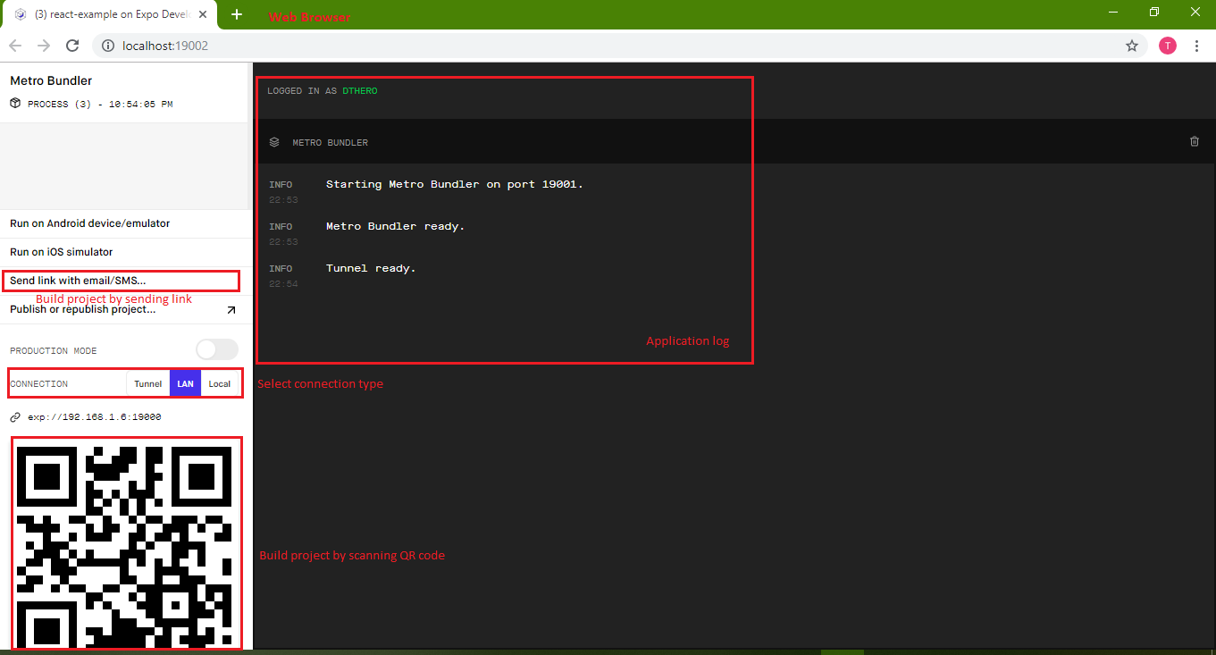

Figure 17 - Expo Web Browser UI

### **4.2. Expo log**

Writing to the logs in an Expo app works just like in the browser: use console.log, console.warn and console.error. Note: Expo does not currently support console.table outside of remote debugging mode [1].

If you use Expo CLI, bundler logs and app logs will both automatically stream as long as your project is running. To stop your project (and end the logs stream), terminate the process with ctrl+C [2].

### **4.3. Why Expo**

Expo makes code project easier to deploy, maintain and execution. When you don't want to use Expo, eject your project from the Expo Client without effect to code running.

Pros of Expo:

+ Over the air updates.

+ An easy and more reliable way of upgrading React Native versions.

+ Limitation of Android Studio/XCode configurations.

+ Certificates management with Apple or Keystores management with Google.

+ Easy to integrate with other services.

+ Sending Push Notifications.

+ Additional, easy to use modules such as Authentication Session or Blur View.

## **5. Open source**

### **5.1. react-native-maps**

react-native-maps is an open source for using map view in React Native. It includes many useful component APIs to interact between user and map.

You can integrate react-native-maps with google map by using Google API key and add it into your application.

### **5.2. react-native-elements**

react-native-elements is a collection of pretty component UI using in React Native such as Button, Input, Checkbox, etc. it also includes a set of complex components and makes as only one component like Rating, Search Bar, Avatar, etc.

react-native-elements helps to make an application using React Native look more beautiful and more natural to develop complex components.

### **5.3. geolib**

geolib is a library developed entirely by Javascript and using calculation algorithms to estimate the result based on coordinates.

geolib contains almost full of needed functions to get data with coordinates:

+ Calculate the distance between 2 points.

+ Get the centre point of the given list.

+ Verify that point satisfy conditions, etc.

### 

### **5.4. react-native-scrollable-tab-view**

react-native-scrollable-tab-view is a library written by Javascript-only for React Native. It uses navigate functions to define a navigation pattern on iOS and Android, and it helps navigation between components and pages become easier and makes UI look more clearly, suit with modern mobile application trend.

### **5.5. material-ui**

material-ui is a great library/framework for developing React Js. It is a set of UI components following Google’s Material Design, including complicated component like Steppers, Date Picker, etc.

It also integrates a huge storage of vector icons and color theme. So you can do anything with your UI component by using material-ui.

# **III. SYSTEM ARCHITECTURE**

**\* System requirements:**

I will divide my group users into two groups:

+ User (visitor), member: Customers using my app on a smartphone.

+ Administrator, owner: The event’s hosts using web UI app to manage their events.

My project will have two parts using React:

+ First is client side for user, and it is a mobile application built on multi-platform and include main features to the user.

+ Second is server side for event’s owner and administrator, it is a web UI application and contains some features help administrator can manage data and owner manage their event.

## **1. Use case by user-stories**

### **user (visitor, member).**

1. Display Login page to register/login

|  |  |
| --- | --- |
| *As a* | visitor |
| *I want to* | See all information on Login page. |
| *so that I can* | Register new account or login to application. |

1. Register new account

|  |  |
| --- | --- |
| *As a* | visitor |
| *I want to* | Register new account |
| *so that I can* | Login into application. |

1. Login an account

|  |  |
| --- | --- |
| *As a* | user |
| *I want to* | Login to application by my account. |
| *so that I can* | Use all features of application. |

1. Display homepage

|  |  |
| --- | --- |
| *As a* | user |
| *I want to* | see all information of Login page when open an app on smartphone. |
| *so that I can* | login by created account or register new account for using app. |

1. Navigate between tabs

|  |  |
| --- | --- |
| *As a* | user |
| *I want to* | see all information of Main page whenever I logged in successfully. |
| *so that I can* | navigate between tabs and see all information of each tab. |

1. Search events

|  |  |
| --- | --- |
| *As a* | user |
| *I want to* | use search tool. |
| *so that I can* | search keywords of the event on News tab and Tournaments tab. |

1. Display News page

|  |  |
| --- | --- |
| *As a* | user |
| *I want to* | see all information of events that are approved from administrator in form of list on News Tab. |
| *so that I can* | View new event created and refresh list event. |

1. Manage push notification

|  |  |
| --- | --- |
| *As a* | user |
| *I want to* | Turn event’s notification on or off. |
| *so that I can* | Manage all notifications that I responded. |

1. Display event detail

|  |  |
| --- | --- |
| *As a* | user |
| *I want to* | see detail of event. |
| *so that I can* | enroll, comment or view detail about the event. |

1. Display map view

|  |  |
| --- | --- |
| *As a* | user |
| *I want to* | see map view on Map tab. |
| *so that I can* | Find all events near me |

1. Filter map view event by radius

|  |  |
| --- | --- |
| *As a* | user |
| *I want to* | Filter map view by radius |
| *so that I can* | Find all events near me. |

1. Filter map view event by sport type

|  |  |
| --- | --- |
| *As a* | user |
| *I want to* | Filter map view by sport type |
| *so that I can* | Find all events near me. |

1. Display personal information

|  |  |
| --- | --- |
| *As a* | user |
| *I want to* | see all information of user on Personal Info tab. |
| *so that I can* | Update and view all personal information. |

1. Take a photo

|  |  |
| --- | --- |
| *As a* | user |
| *I want to* | Take a photo using my device’s camera. |
| *so that I can* | Update picture into application. |

1. Comment on event

|  |  |
| --- | --- |
| *As a* | user |
| *I want to* | Comment on specific event. |
| *so that I can* | Update my comment into event detail successfully. |

1. Receive push notification

|  |  |
| --- | --- |
| *As a* | user |
| *I want to* | Receive push notification from application. |
| *so that I can* | Know news about events. |

1. Re-render map when location change

|  |  |
| --- | --- |
| *As a* | user |
| *I want to* | Filter map by changing my current location. |
| *so that I can* | Find all events near me. |

1. Change personal picture

|  |  |
| --- | --- |
| *As a* | user |
| *I want to* | Take or choose a picture. |
| *so that I can* | Update my avatar into new one. |

### **1.2. Owner, Administrator.**

1. Login to web UI

|  |  |
| --- | --- |
| *As an* | Owner/administrator |
| *I want to* | Login to web UI by my account |
| *so that I can* | Use all features of an event owner. |

1. Register new account

|  |  |
| --- | --- |
| *As an* | Owner/administrator |
| *I want to* | Register new account |
| *so that I can* | Login to web UI by created account. |

1. Create new event

|  |  |
| --- | --- |
| *As an* | owner |
| *I want to* | Fill all data to create new event. |
| *so that I can* | Create a new event successfully on database. |

1. Remove event

|  |  |
| --- | --- |
| *As an* | Owner/administrator |
| *I want to* | Remove a created event |
| *so that I can* | Delete event successfully from database. |

1. Update event

|  |  |
| --- | --- |
| *As an* | Owner/administrator |
| *I want to* | Update status of the event (Approved/Rejected/Pending) |
| *so that I can* | Update successfully to database. |

1. Filter event by alphabet

|  |  |
| --- | --- |
| *As an* | Owner/administrator |
| *I want to* | Filter list of events by alphabet |
| *so that I can* | See all events easily in Events tab. |

1. Change user

|  |  |
| --- | --- |
| *As an* | administrator |
| *I want to* | Add/update/remove user |
| *so that I can* | Update user successfully to database. |

1. See Dashboard

|  |  |
| --- | --- |
| *As an* | administrator |
| *I want to* | See all dashboard chart of events management. |
| *so that I can* | Know the information about all events in database. |

## **2. Diagrams**

Figure 18 - Use case diagram for client

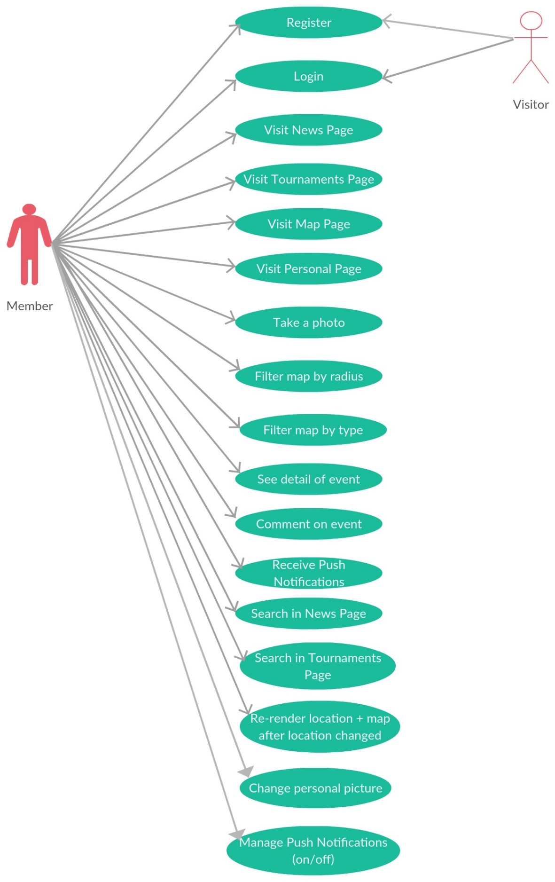

Figure 19 - Use case diagram for server

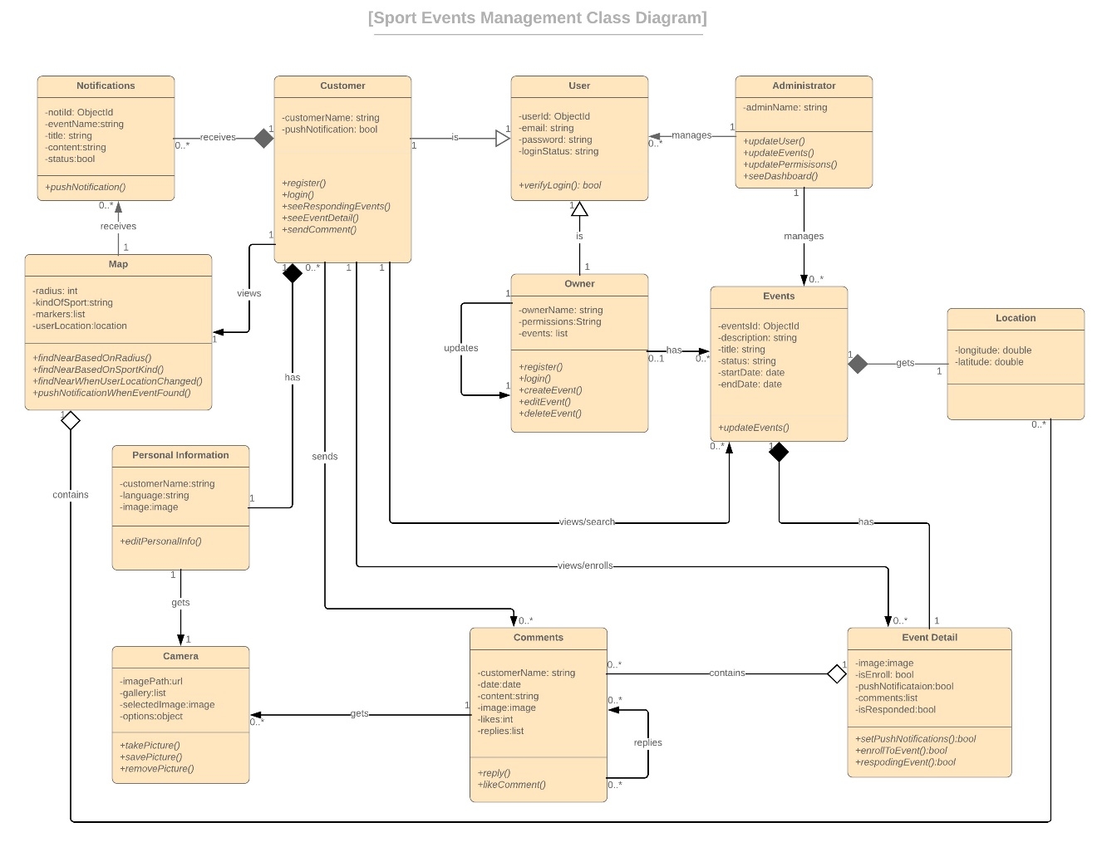

Figure 20 - Sport Events Management Class diagram

# **IV. IMPLEMENTATION**

* In my project, I apply technologies following these layers:

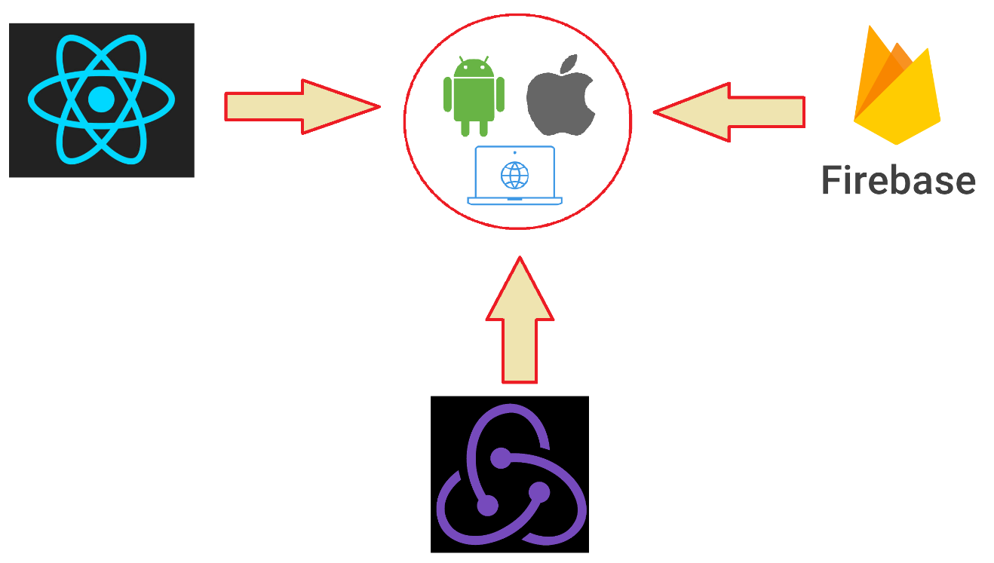

Figure 21 - Applying technologies into project

* Go to details, we have:

- React (React Native + React JS):

+ Use to build an UI for handling view layer of single page applications (React JS for Web and React Native for Mobile).

+ Create UI components for reuse.

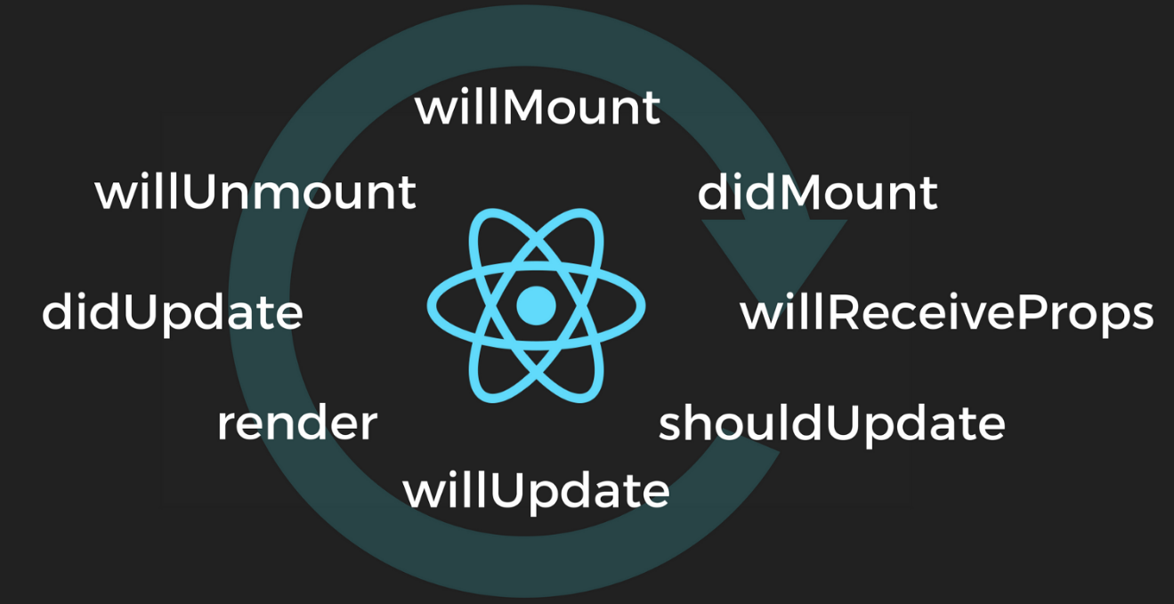

Figure 22 - React Life Cycle

- Redux:

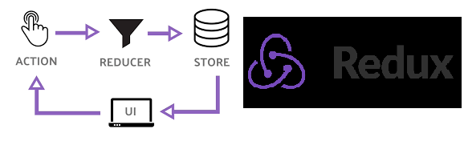+ Apply Redux to control the state of application by providing "Unidirectional Data Flow" (UDF), then it helps to keep code in order and more flexible to maintain.

Figure 23 - Redux Model

- Firebase:

+ To manage the backend database and trigger at the real time.

+ Integrate with various kinds of features to make application working smoothly.

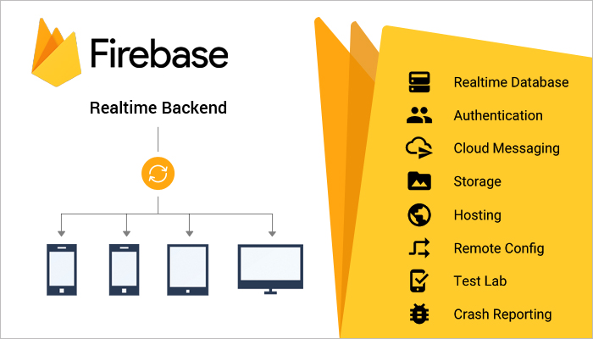

Figure 24 - Firebase features

## **1.** **Layers, functions**

### **1.1. Mobile Application**

#### ***1.1.1. Overall structure***

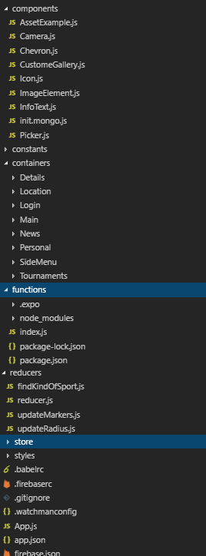- List of code structures:

Figure 25 - Code structure

+ component: Reuse UI components

+ constants: Storage of constants

+ containers: Contains all UI components for using in application’s features:

Details: Event detail feature

Location: Map feature

Login: Login feature

Main: Main page, contains all other UIs.

News: News feature

Personal: Personal Information feature

Tournaments: Event responding feature

+ functions: Container of Google Firebase - Cloud function

+ reducers, store: Applying of Redux into project

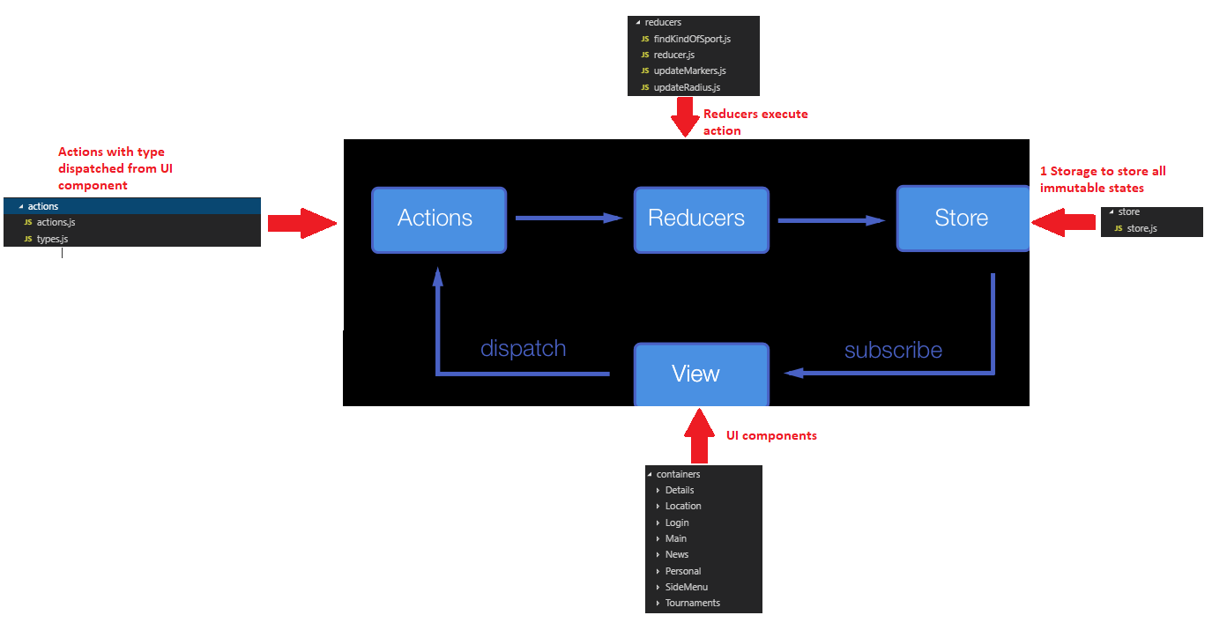- Mapping between packages and Redux:

Figure 26 - Applying of Redux

#### ***1.1.2. Push Notification***

My application using Cloud Function integrate with Expo to send Push Notification at the real time to devices.

To initialize Cloud Function in application, try following steps:

+ Initialize Firebase in product path:

firebase init

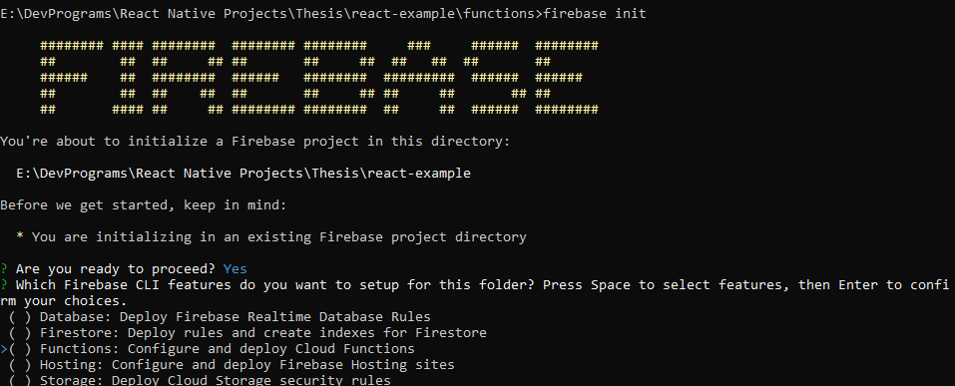 + Type “Y” and select “Functions”

Figure 27 - Firebase cli

+ Select language to write function, then choose the other suitable options with you (in case of mine, I have already do the function before then I choose “N” all)

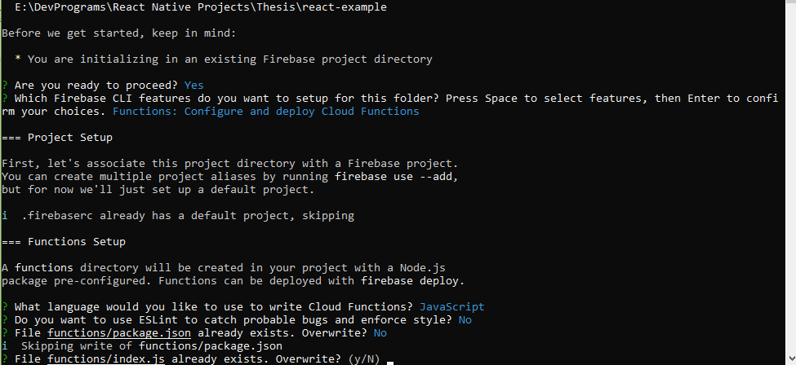

Figure 28 - Initialize Firebase function

+ When select all options and execute, firebase will initialize successfully and show a file name Index.js inside created package “functions”

Next, access to “functions” package and run command to install needed module:

npm install node-fetch

Define your function in “Index.js” file and run command to deploy function on Firebase server:

firebase deploy

Function deployed successfully will show with message “complete”.

To receive notification, you must register your device’s token and there is how your device integrate with Firebase from UI component:

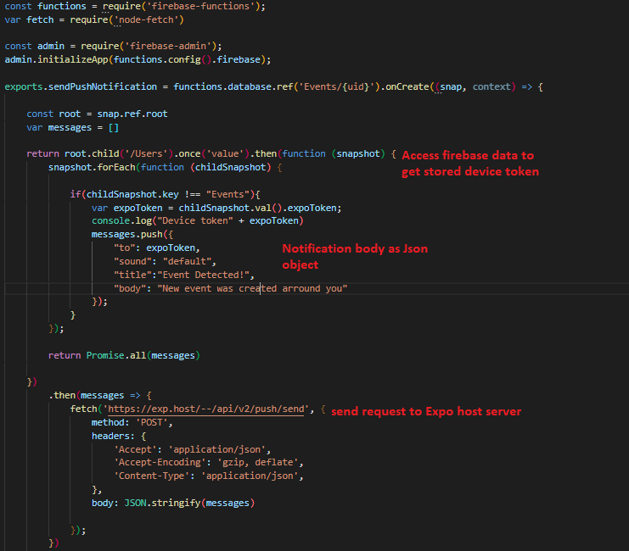

Figure 29 - Write function to send Push Notification in “Index.js”

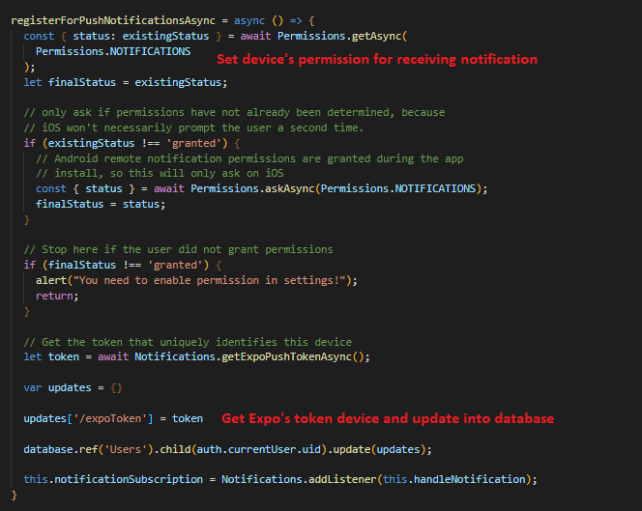

Figure 30 - Register device’s token and update database to receive notification in UI component

#### ***1.1.3. Map View***

Map view in my application use “react-native-map” module integrated by Expo and Google Map API.

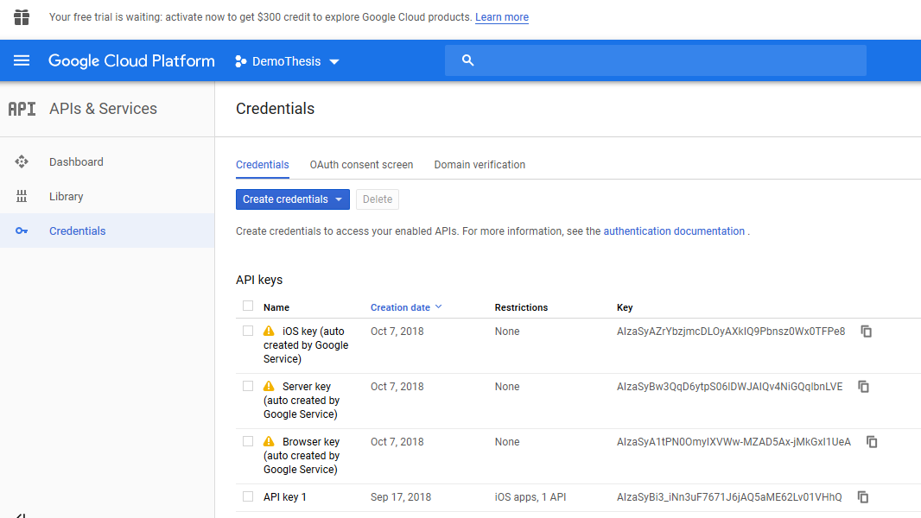First, get Google API by accessing <https://console.cloud.google.com> and register one, the API maybe provided for only mobile platform (iOS or Android) or for general purpose.

Figure 31 - Google Cloud console of managing API keys

To use Google Map in Map View, register it by passing API key into config file of project (in this case is Expo’s app.json file):

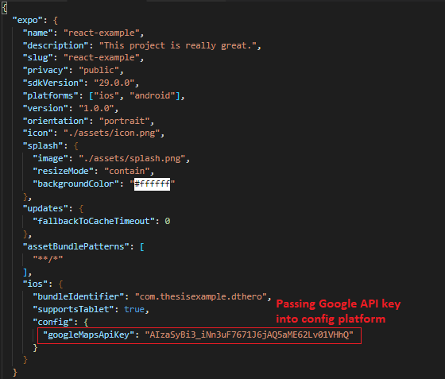

Figure 32 - Expo configuration file

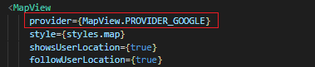Then pass prop of Map View component by Google as provider

Figure 33 - Google provider in Map view

#### ***1.1.4. Camera***

Camera is a reuse component (using in both Event Detail and Personal Information features) so we must put it in “components” package

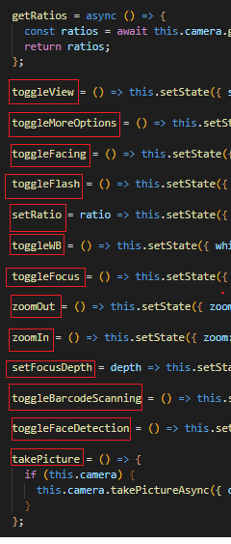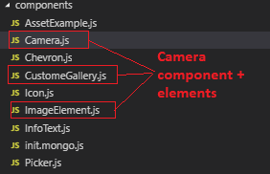

Figure 34 - Actions inside Camera component

Figure 35 - Camera component

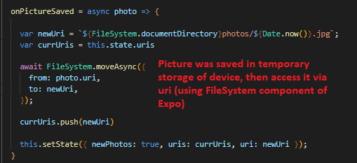

Figure 36 - Image processing in client

### **1.2. Web application**

#### ***1.2.1. Overall Structure***

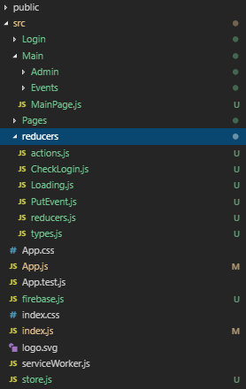

Figure 37 - Web application code structure

- List of features:

+ Login: Login feature

+ Main: Includes Main page and child component (Admin feature + Events feature)

- reducers: Applying of Redux into project

#### ***1.2.2. UI component - Material UI***

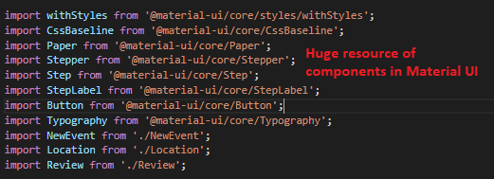Material UI is a great UI framework for developing React JS, with almost full of necessary components for a single page application.

Figure 38 - Material UI components

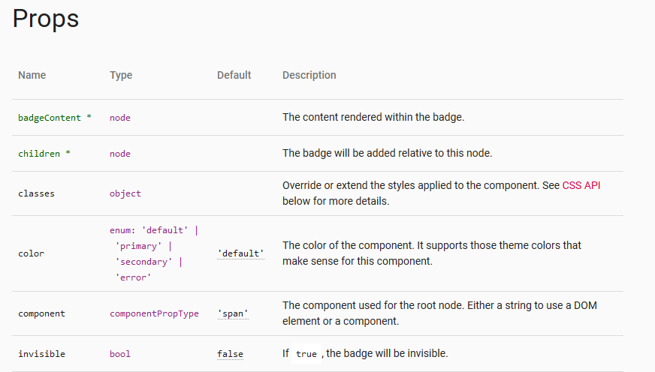It also provides many props relates and need for 1 component

Figure 39 - Material UI component's props

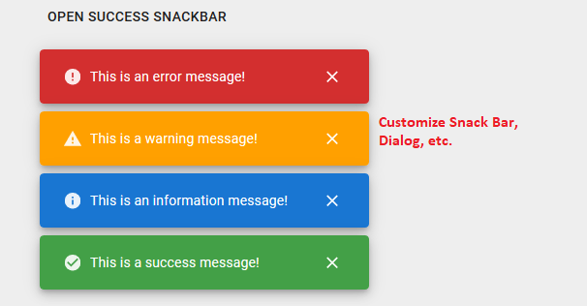Create a complex component to become more straightforward and customizable.

Figure 40 - Material UI Complex components

### **1.3. Redux implementation – react-redux**

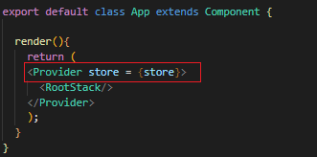Define Redux at root component by providing Store class:

Figure 41 - Initialize redux in application

Combine multi-reducers into only 1 and passing to Store:

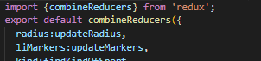

Figure 42 - Redux component combine all reducers

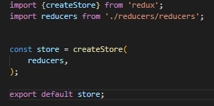

Figure 43 - Initialize store in application

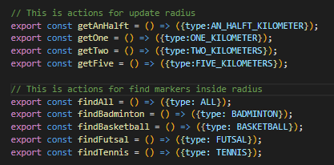Initialize actions as callback functions for reducers:

Figure 44 - Redux actions implementation

To trigger an action from component or update data from Store to View, we need to use connect() function in react-redux. Define all return states of Store as component’s props and import action, then pass it all to connect() function to initialize connection between component and states.

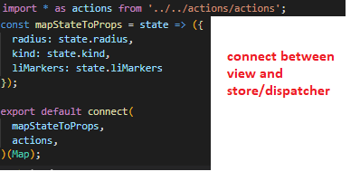

Figure 45 - Connection between Component and Redux

After apply Redux into component, calling actions or getting latest state by using “this.props”

Figure 46 - Redux calling actions in component

### **1.4. Firebase - Realtime Database**

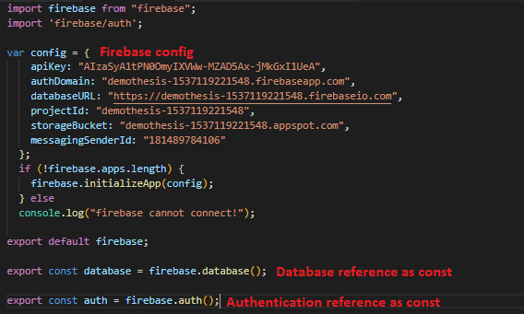To use Firebase database in the project, we must config our mapping project on Firebase console and call it when trigger data, since Firebase config is unchanged, so I saved “firebase.js” config file in “constants” package:

Figure 47 - Firebase config and constant references

To trigger data from server, using const above and access to desired child

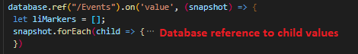

Figure 48 - Firebase database references

Firebase Realtime Database is save as Json object and include Token ID (the same as Object ID) in MongoDB. Each time we push new data into database, we can generate new Token ID data object:

Figure 49 - Firebase push database

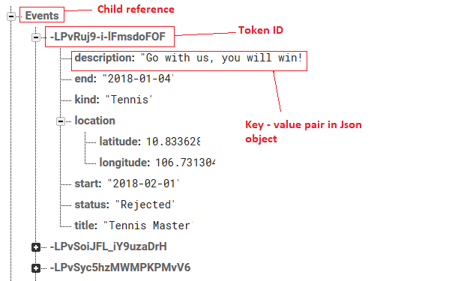

Figure 50 - Firebase Realtime Database view

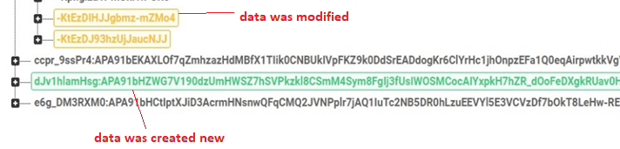

Figure 51 - Firebase synchronous database in real time

Authentication in Firebase is used to verify that whether user has registered or not:

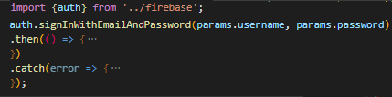

Figure 52 - Using authentication in application

## **2. Result**

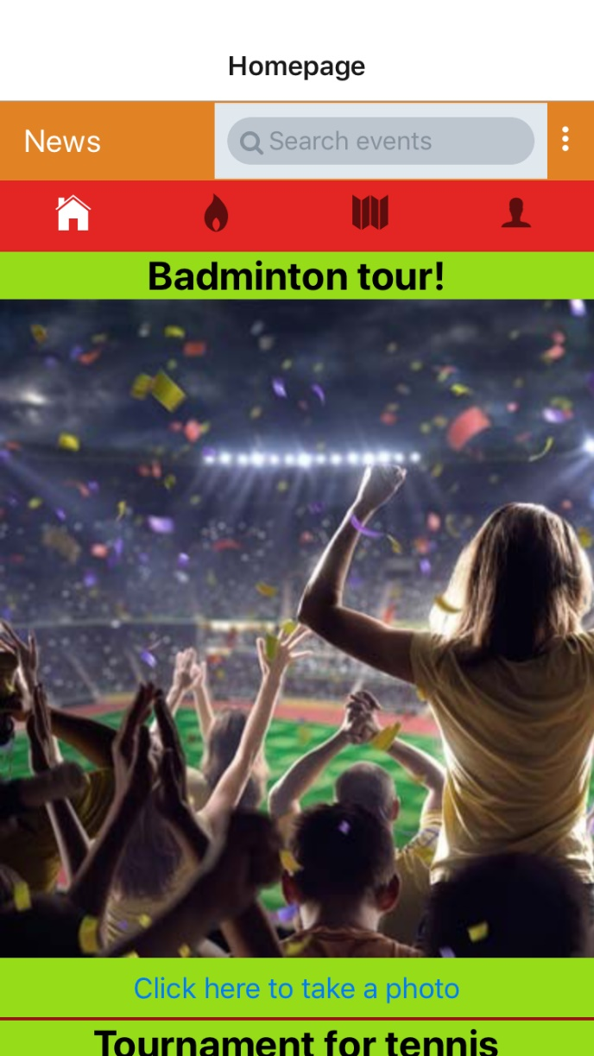

### **2.1. Mobile application**

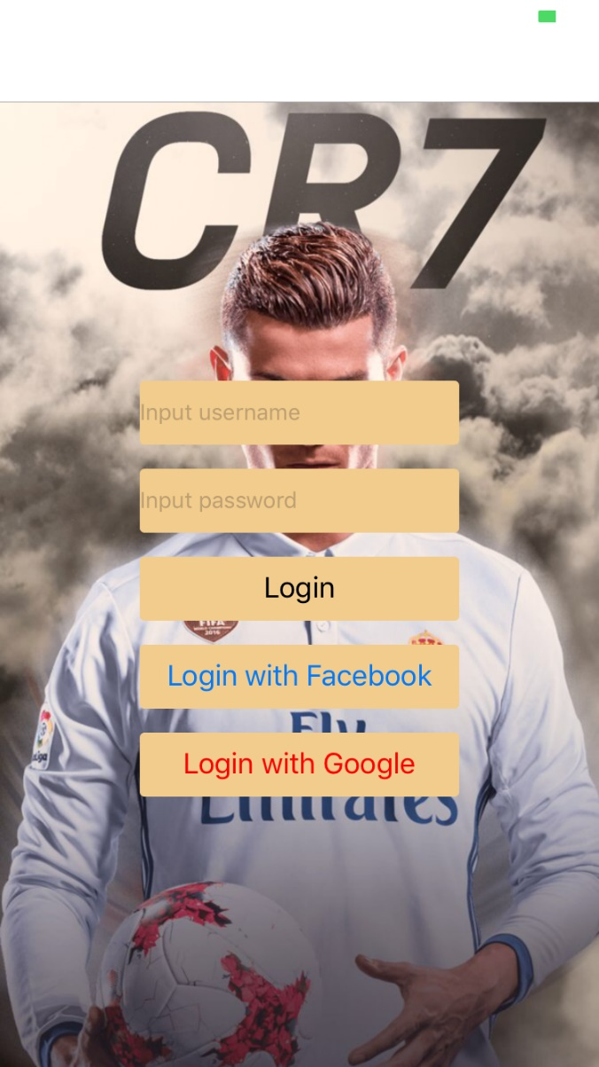

Figure 53 - Login screen

Figure 54 - Main screen

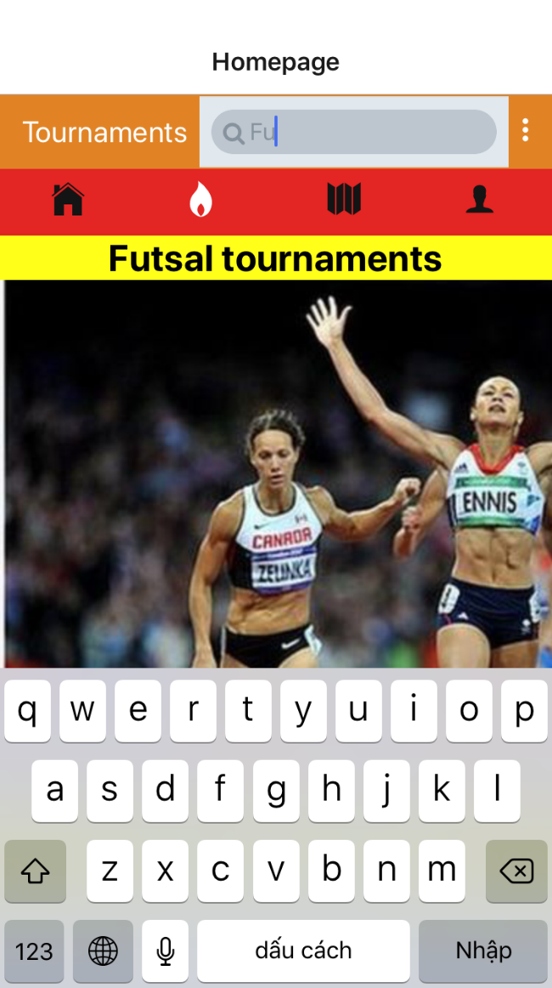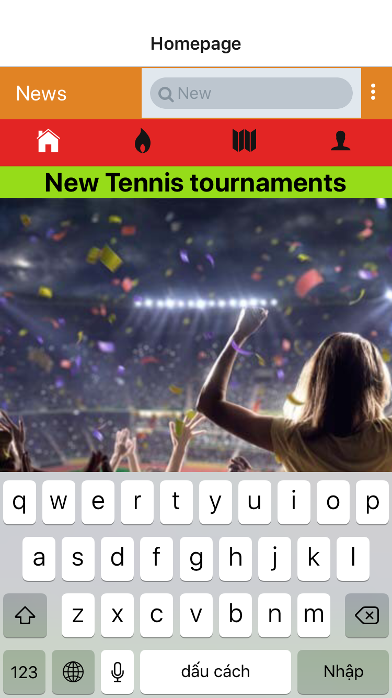

Figure 55 - News tab contains all available events

Figure 56 - Tournaments tab contains specific responded events

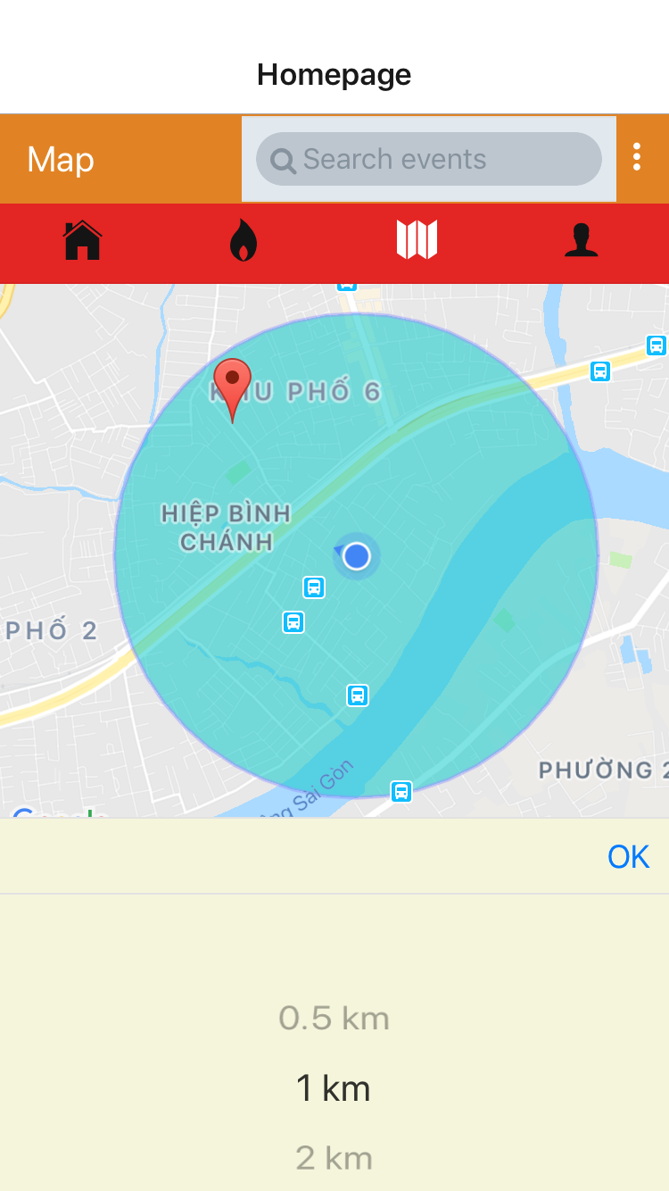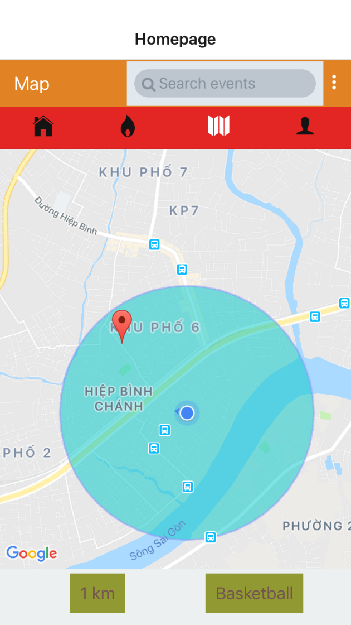

Figure 57 - Map view tab

Figure 58 - Map view tab, radius filter

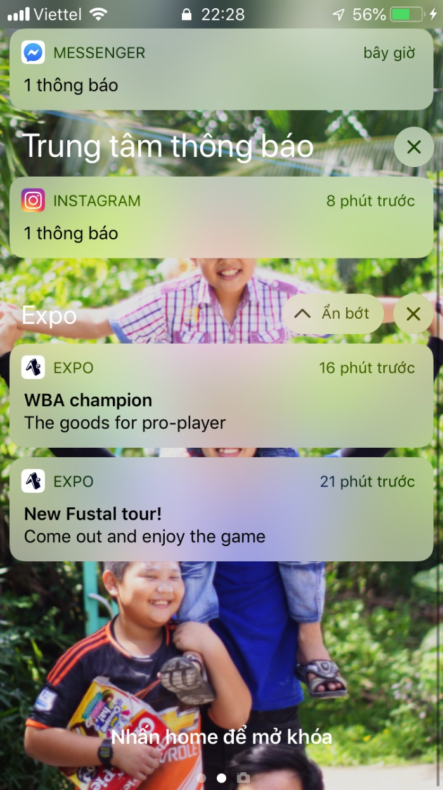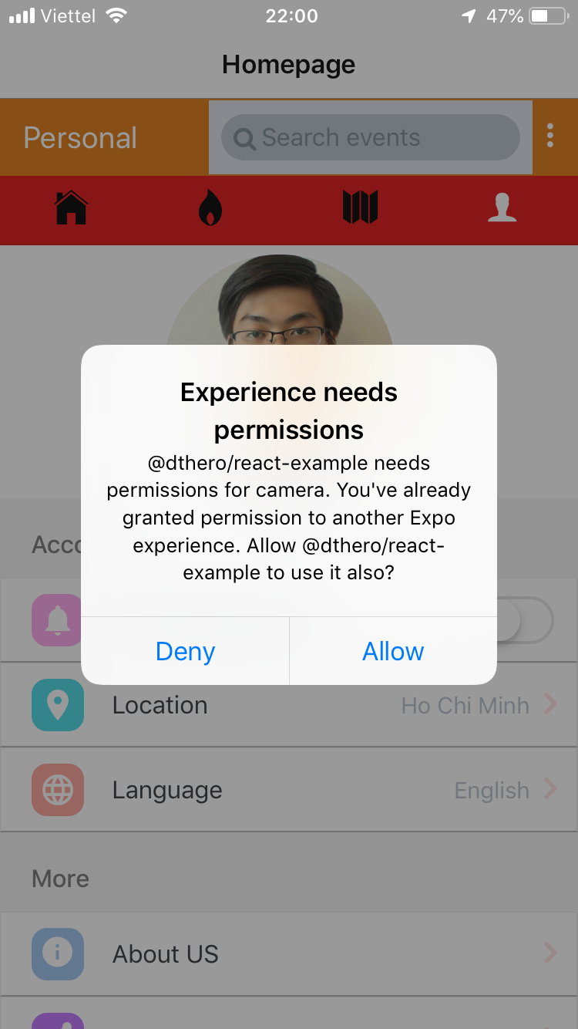

Figure 59 - Personal tab, permission required

Figure 60 - Background theme, push notifications

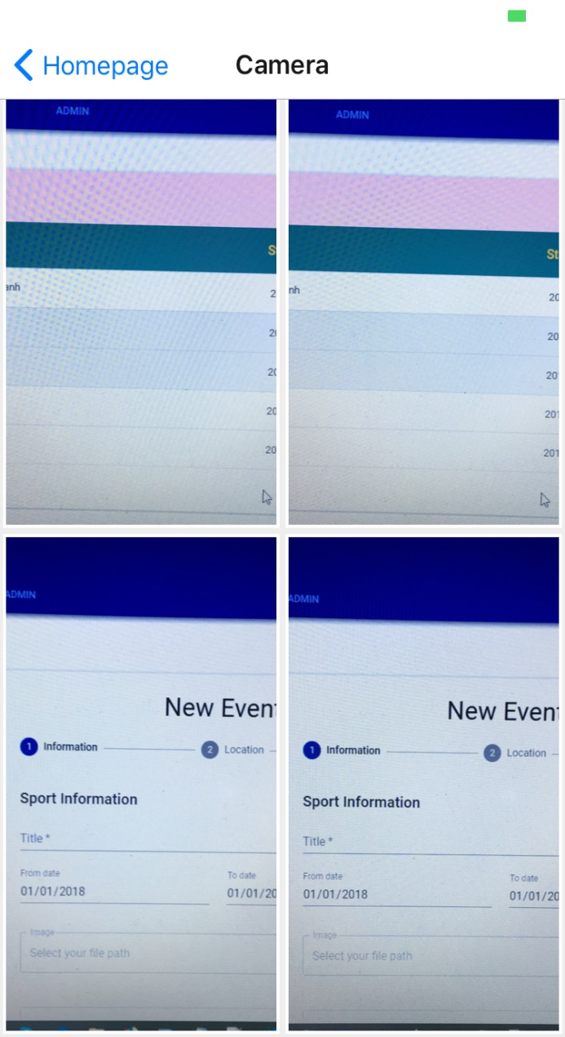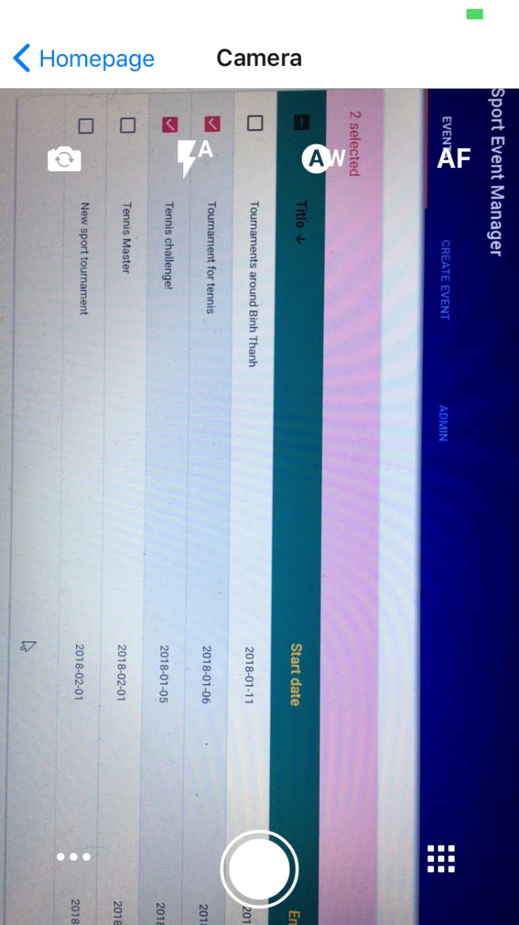

Figure 61 - Camera screen

Figure 62 - Gallery screen, temporary storage

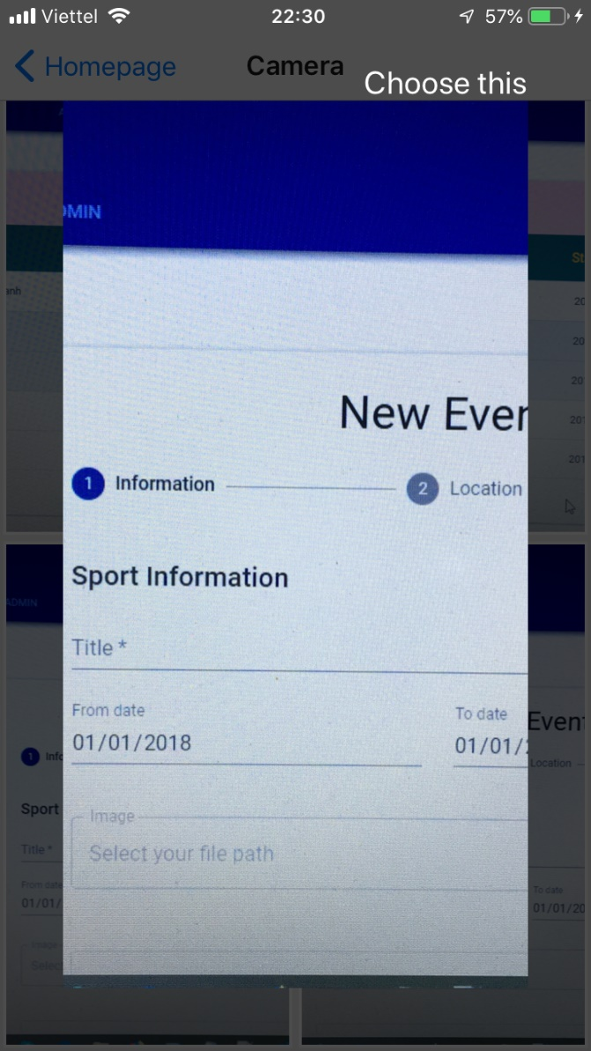

Figure 63 - Image modal review

### **2.2. Web application**

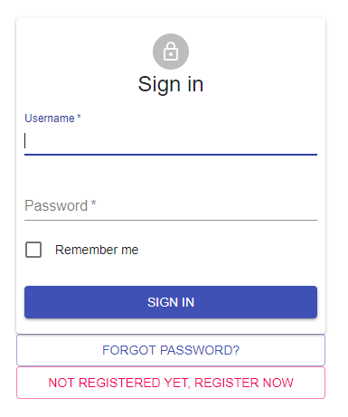

Figure 64 - Sign in page

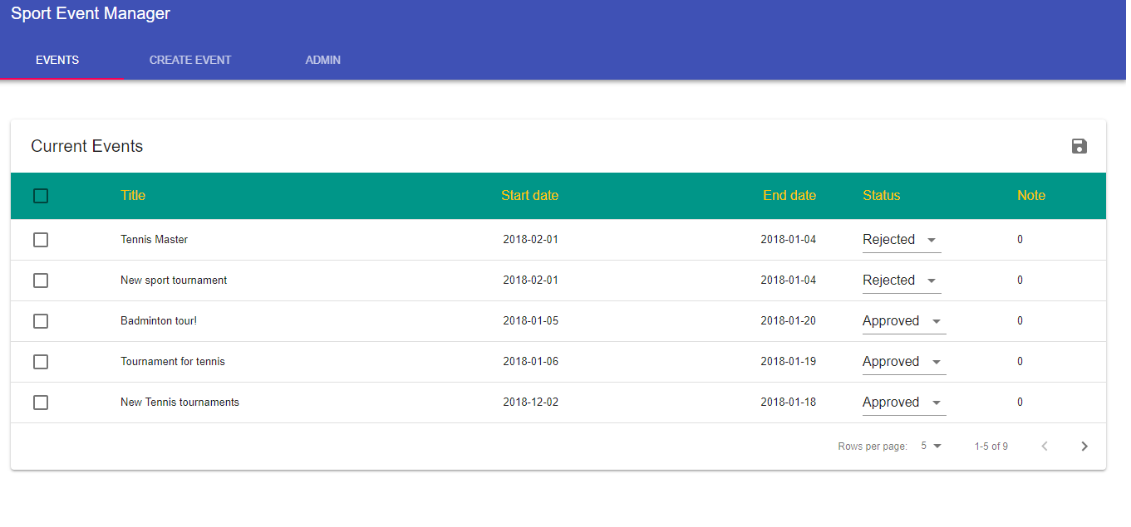

Figure 65 - Event page

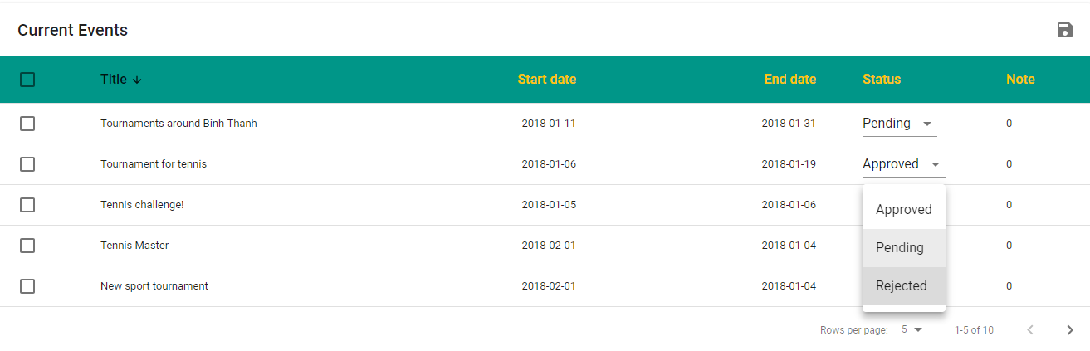

Figure 66 - Filter and update events

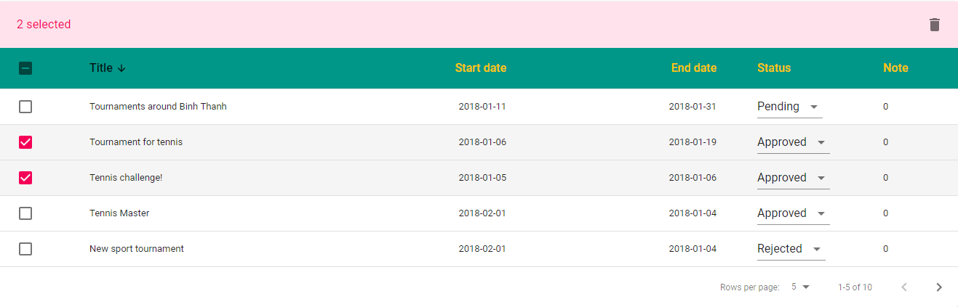

Figure 67 - Delete events

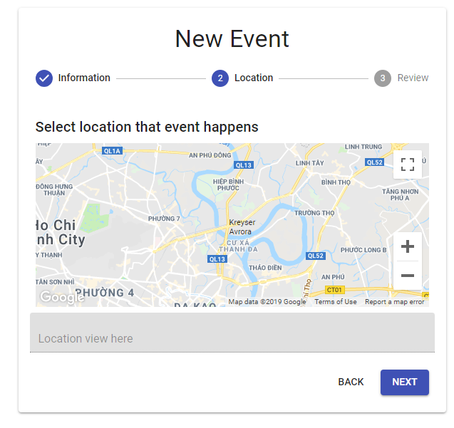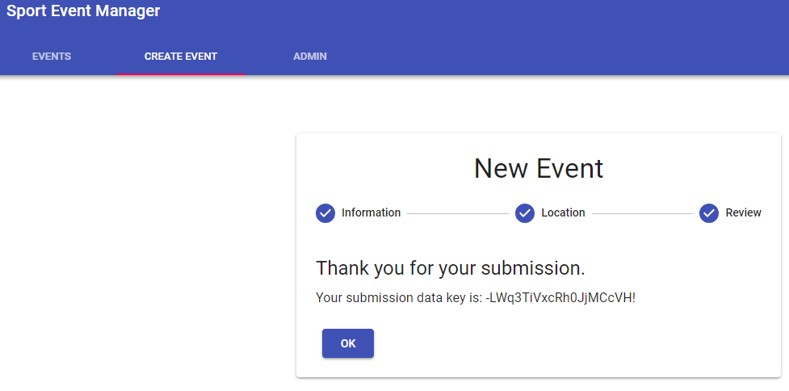

Figure 68 - Added new event

Figure 69 - Adding event steps

# **V. CONCLUSION**

## **1. Experiences**

* I have gained many things after ran this thesis project:

Firstly, I got a knowledge about React Native, a very similar to Javascript language. It is not only easy to learn and build a project by React but also use it to compile and run an application on multi platforms like a native application.

Secondly, through the usage of Firebase, I made the connection to server side easier. In addition, using the combinations of functions in Firebase (Cloud Function, Real time database, Authentication) help to make the application becomes more interactive and works smoothly.

Thirdly, I used NoSQL database for managing data and then it helps me to work with Json - a very popular data syntax - more and more efficiently.

Finally, I have learnt many new technologies and got ability to work with new frameworks/environments. Using React Native helps me have experience to build a native application on mobile based on a single language, it will help me a lot in the future if becoming a mobile developer is the way for myself.

## **2. Conclusion**

React Native is gradually confirmed that it is one of the best language using for developing application on mobile. It is not for a specific platform, but it can also be embedded native language and build like a native application. The libraries of React Native is developed more and more, so it is easy to find one that satisfy product requirements.

Besides that, using Flux architecture also help to manage product more efficiently. Applying Flux makes states is more clearly, so it makes application is easier to maintain and update.

Firebase is also a good platform for developing mobile and web application. It contains many solutions help to manage and use data, especially notifications and messages system, etc. It also provides the storage to store/retrieve data as Json object at real time, which is very convenient for online applications on mobile.

# **REFERENCES**

[1], [2] <https://docs.expo.io/versions/v31.0.0/workflow/logging>

[3] <https://firebase.google.com/docs/database/security>

[4], [5] <https://firebase.google.com/docs/database>